Instructions

Student’s Name
Institutional Affiliation
Course Name and Number
Instructor’s Name
Assignment Due Date

Memo
To:
From:
Date:
Re:

Introduction
East Carolina University (ECU), is a nationwide recognized university and is determined to be a national model for student success, public service and regional transformation. However, new students may find it hard to track their admission status given that they have little experience on the institution information systems. The orientation team ensures that these students get directions in order to help them trace their admission status once they have applied online. This set of instructions is useful for new students to ECU. The directions are aimed at ensuring smooth and timely transition to campus from home. The instructions are precise and easy to understand.
Questions
- What is the use of this set of directions?
This set of instructions equips the user to know when their admission is successful, since most of the admission is applied online.

- What information is included in this set of directions?
This guide contains navigator tools that allow the user to access the admission services. Therefore, the user must be equipped with good Information computer and internet skills.
- Why this guide?
Many new students get students get stuck after they have submitted their admission application successfully. Hence, this set of instructions come in handy to help them know how to monitor progress of their application.

What you need
- Computer or any device to access the internet.
- Internet connection
- Admission credentials including your username and password.

Purpose statement
Navigator, ECU’s admissions portal, is designed to help personalize your admissions experience. Once you create an account, you can: Apply for admission, track your admission status receive information pertaining to your specific academic interests and more!

Instructions
- Go to your internet browser. Then input the URL
https://admissions.ecu.edu/

This will take you to ECU admissions home page.
This page contains six items on the top bar
- Explore
- Visit
- Apply
- Enroll
- Afford
- Connect


- Click the button apply
It will give you a down menu that contains:
- Freshmen, Transfers, Readmission, Second degree, Post Baccalaureate Teacher Licensure, Military students & Veterans, Visiting students, International
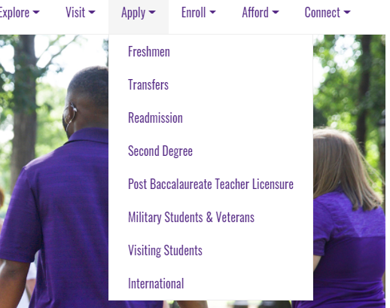
- Click the button Freshmen
This will take you to a page that contains the following items: freshmen core requirements, supplemental notices, how to apply, dates and deadlines and residency determination. It also contains a button at the bottom left corner. This create account or login button requires you to create a navigation account.
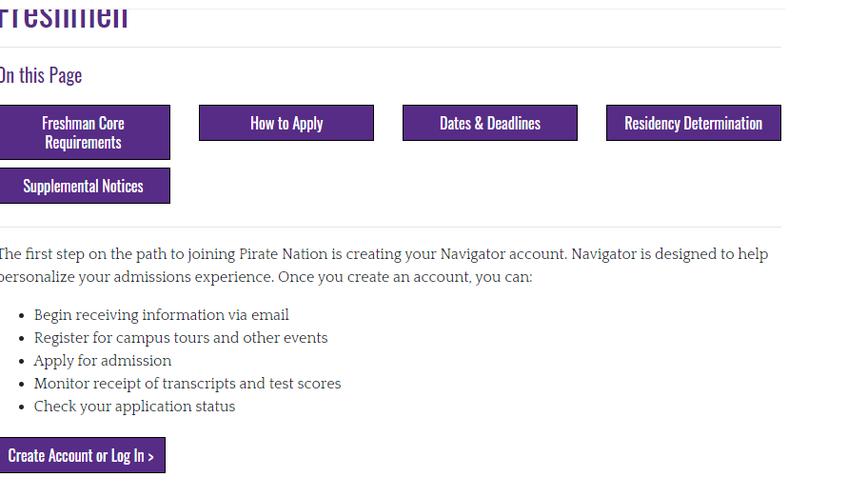
- Click the create account button. By clicking here, you will be taken to a page where you are required to login or create a navigator account. This account will be important in personalizing admission experience of the freshmen.
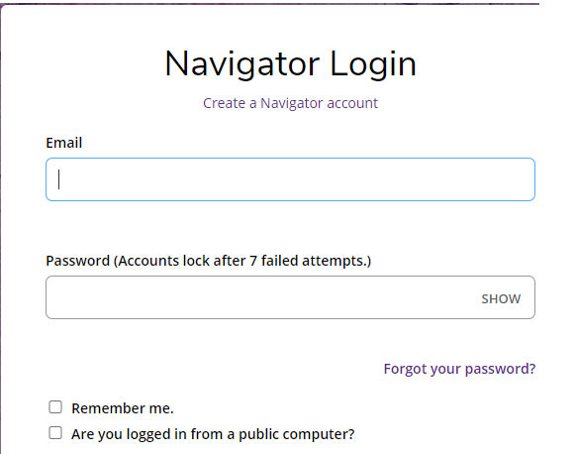

- Click create a navigator account then you will be taken to the creation of account page. This page contains: student contact information which includes your name (first name, full middle and last name), birth date. It also contains a part of student e-mail address – in this section there is a disclaimer that parents should not create an account for themselves or on behalf of their students. This instruction should be heeded because it brings issues during the admission process.

The page looks like the following:
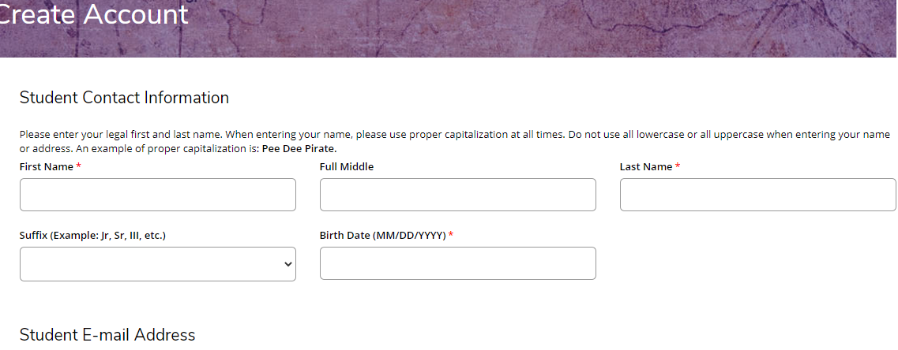
- Make sure, after filling the information in this section, to click the create account button.
- Then the system will generate a one-time activation code to your e-mail.
- Use the activation code to activate your navigator account.

- Return to home page.
- Click apply online
- This takes you to a page requiring you to login to your navigator account.

- Login to your navigator account using your email and password.
- This will take you to a page that contains your profile information.
- It also contains important application information. Fill out the online application as thoroughly as possible. Failure to provide complete, accurate, and truthful information on this application will be grounds to deny or withdraw your admission, or dismiss you after enrollment.
- It also contains a part for application selection. Remember that there are three ways to apply for admission. You can apply through ECU navigation account, or through CFNC or through common App. In order to experience the full functionality of our Admissions Portal, we encourage you to use a current version of Internet Explorer, Mozilla Firefox, or Safari to apply to East Carolina University.
- Please select the description that best describes your current academic background.
- Also this page contains a part on application review status. In this part there a tab that shows you your current application status. You can also check your progress at the bottom button showing your application type.
The page will look like displayed below:
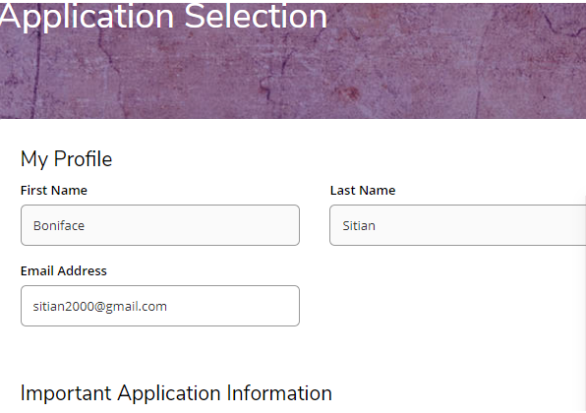
The bottom page looks like displayed below:
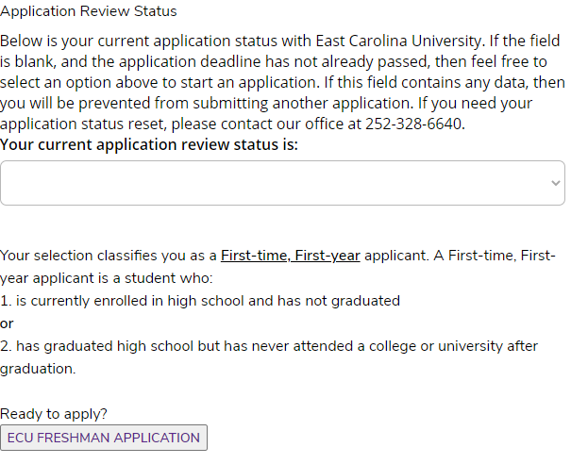

What to remember:
- When you submit your completed application, you will be asked to provide information for a valid credit or debit card to pay the NON-REFUNDABLE $75 application fee.
- Please note that admission to the university does not guarantee admission to all degree programs, many of which have additional application procedures and requirements.
- Please allow 2-3 business for your application to sync with your account.
- After 2-3 business days, if you do not see your application, email ugops@ecu.edu to merge your account with your CFNC or Common Application.

